

Setting up your Stripe Account – Sole Trader

1. Start the Signup Process
- Click the link in the email titled – “Welcome to Itzhome! Lets Set Up Your Account for Smooth Payouts”

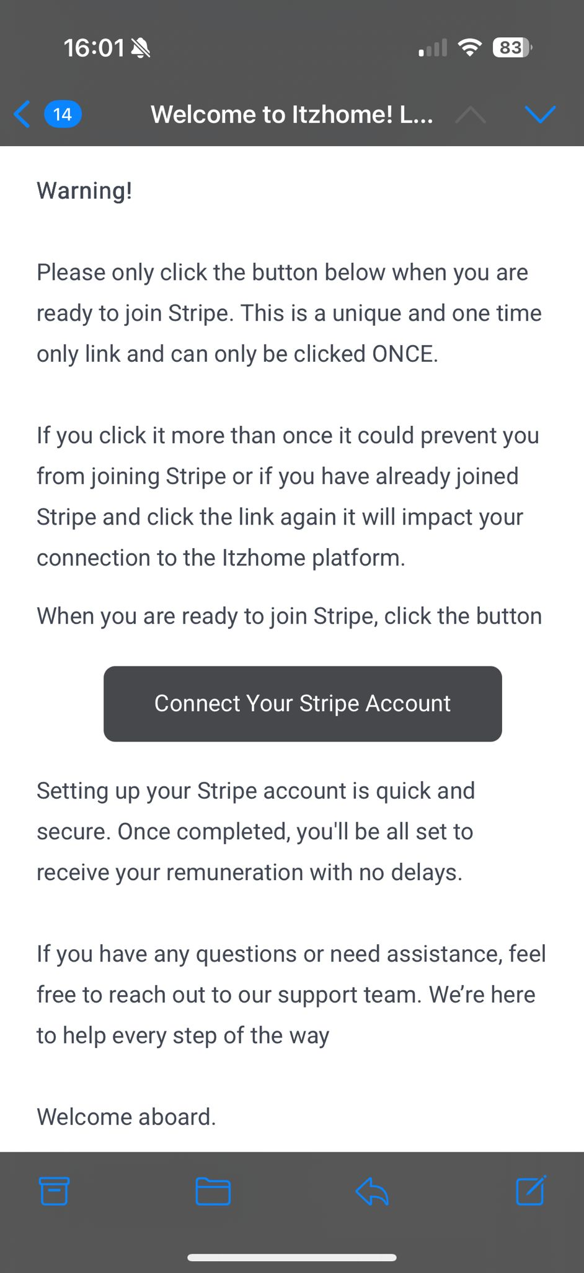

- Enter your email address and click Submit
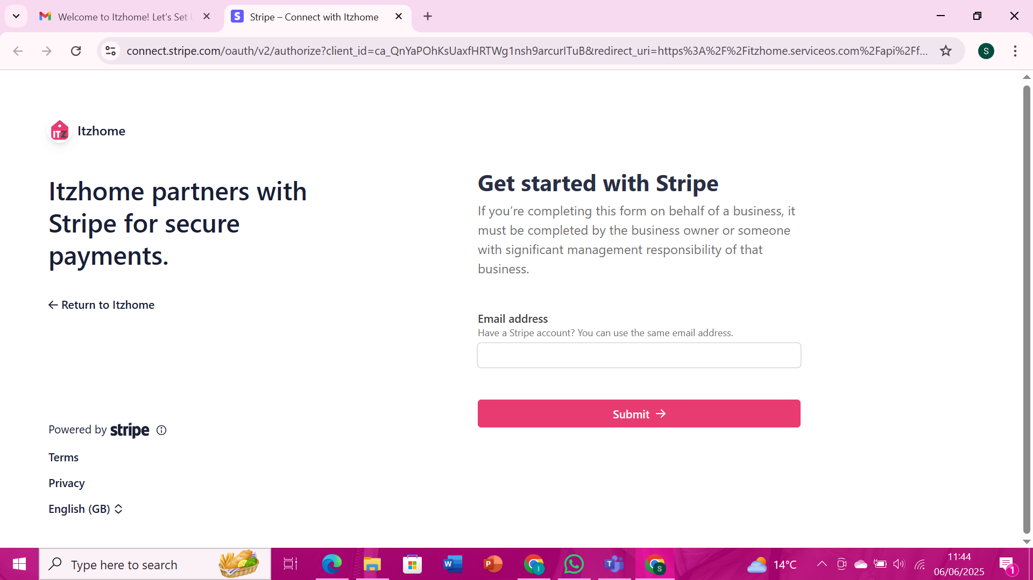

- Create a password and click Submit

2. Set Up Two-Factor Authentication
- Download Google Authenticator (if not already installed) – available on App Store and Google Play.

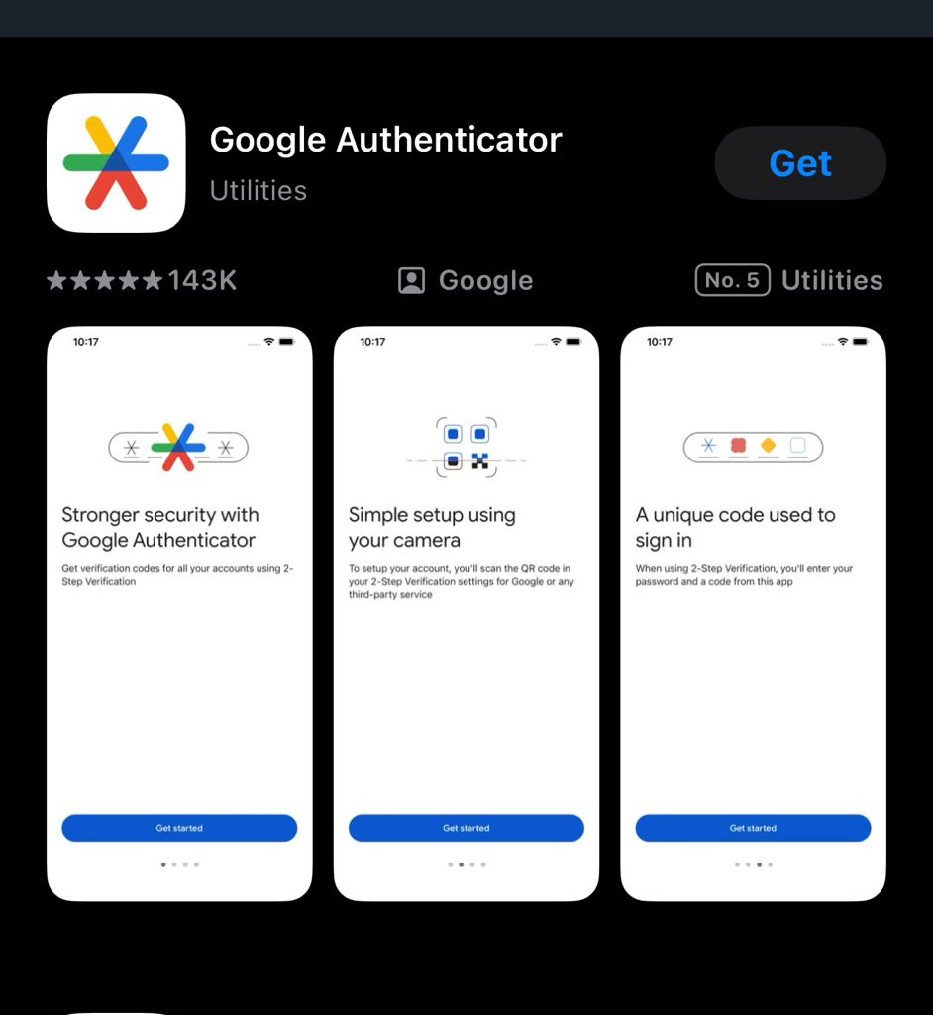
- Copy the unique two-step authentication code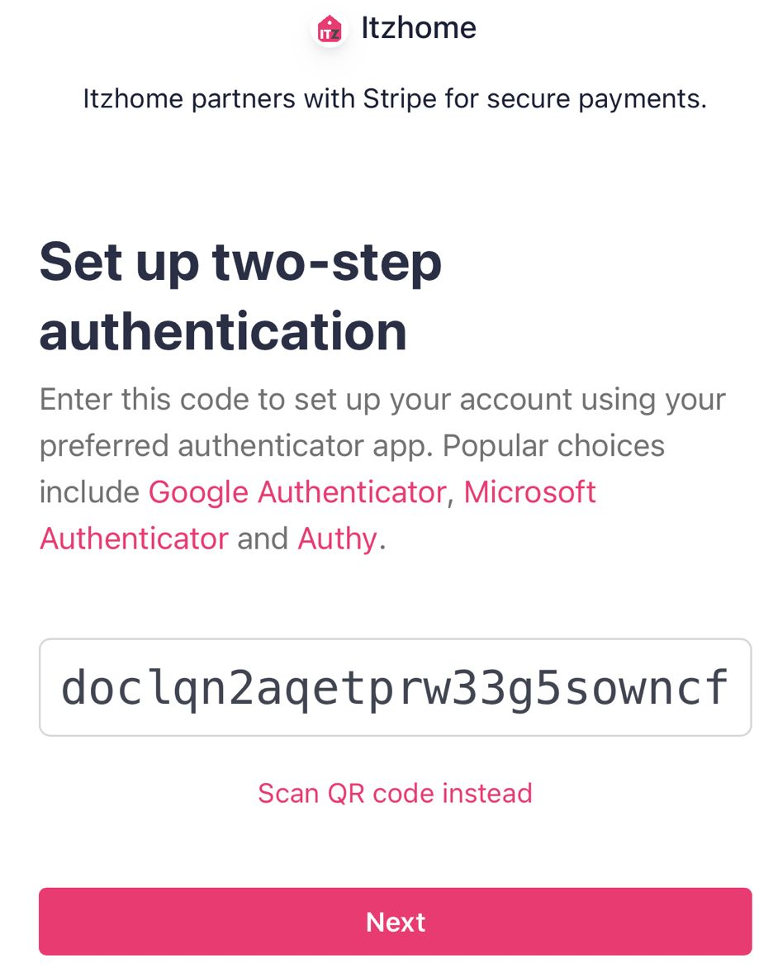

- Then open Google Authenticator and click on “Enter a setup Key”
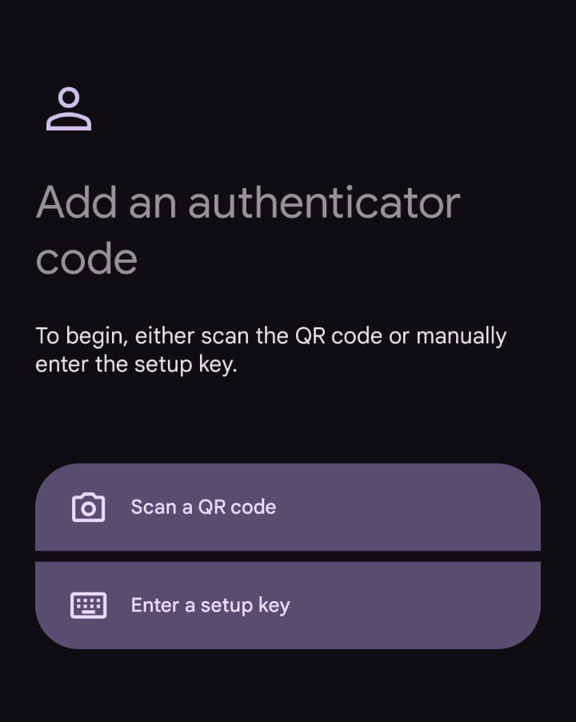

- After, on the Enter Code Details Screen add the following details:
Codename: Itzhome
Your Key: <insert your authentication code here> (you should of copied it previously on Stripe)
Type of Key: Time Based

And hit Add

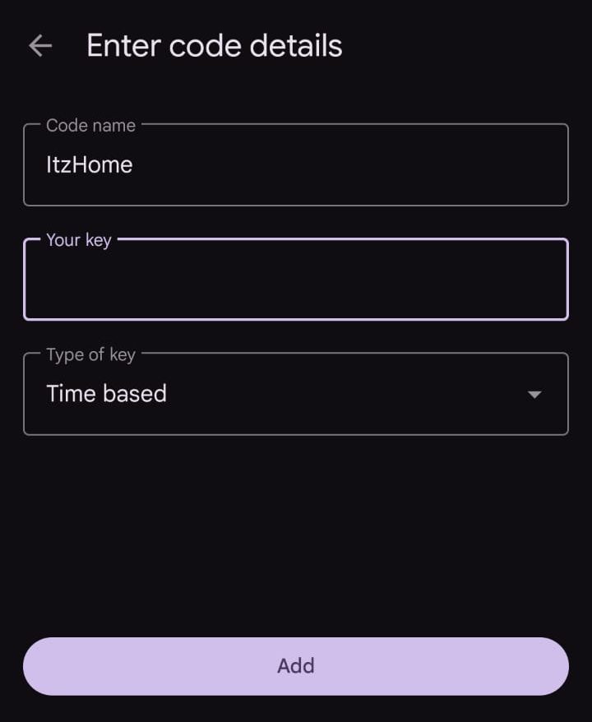

- You will then be given a 6 digit code to input into Stripe (the code changes every 30 seconds)

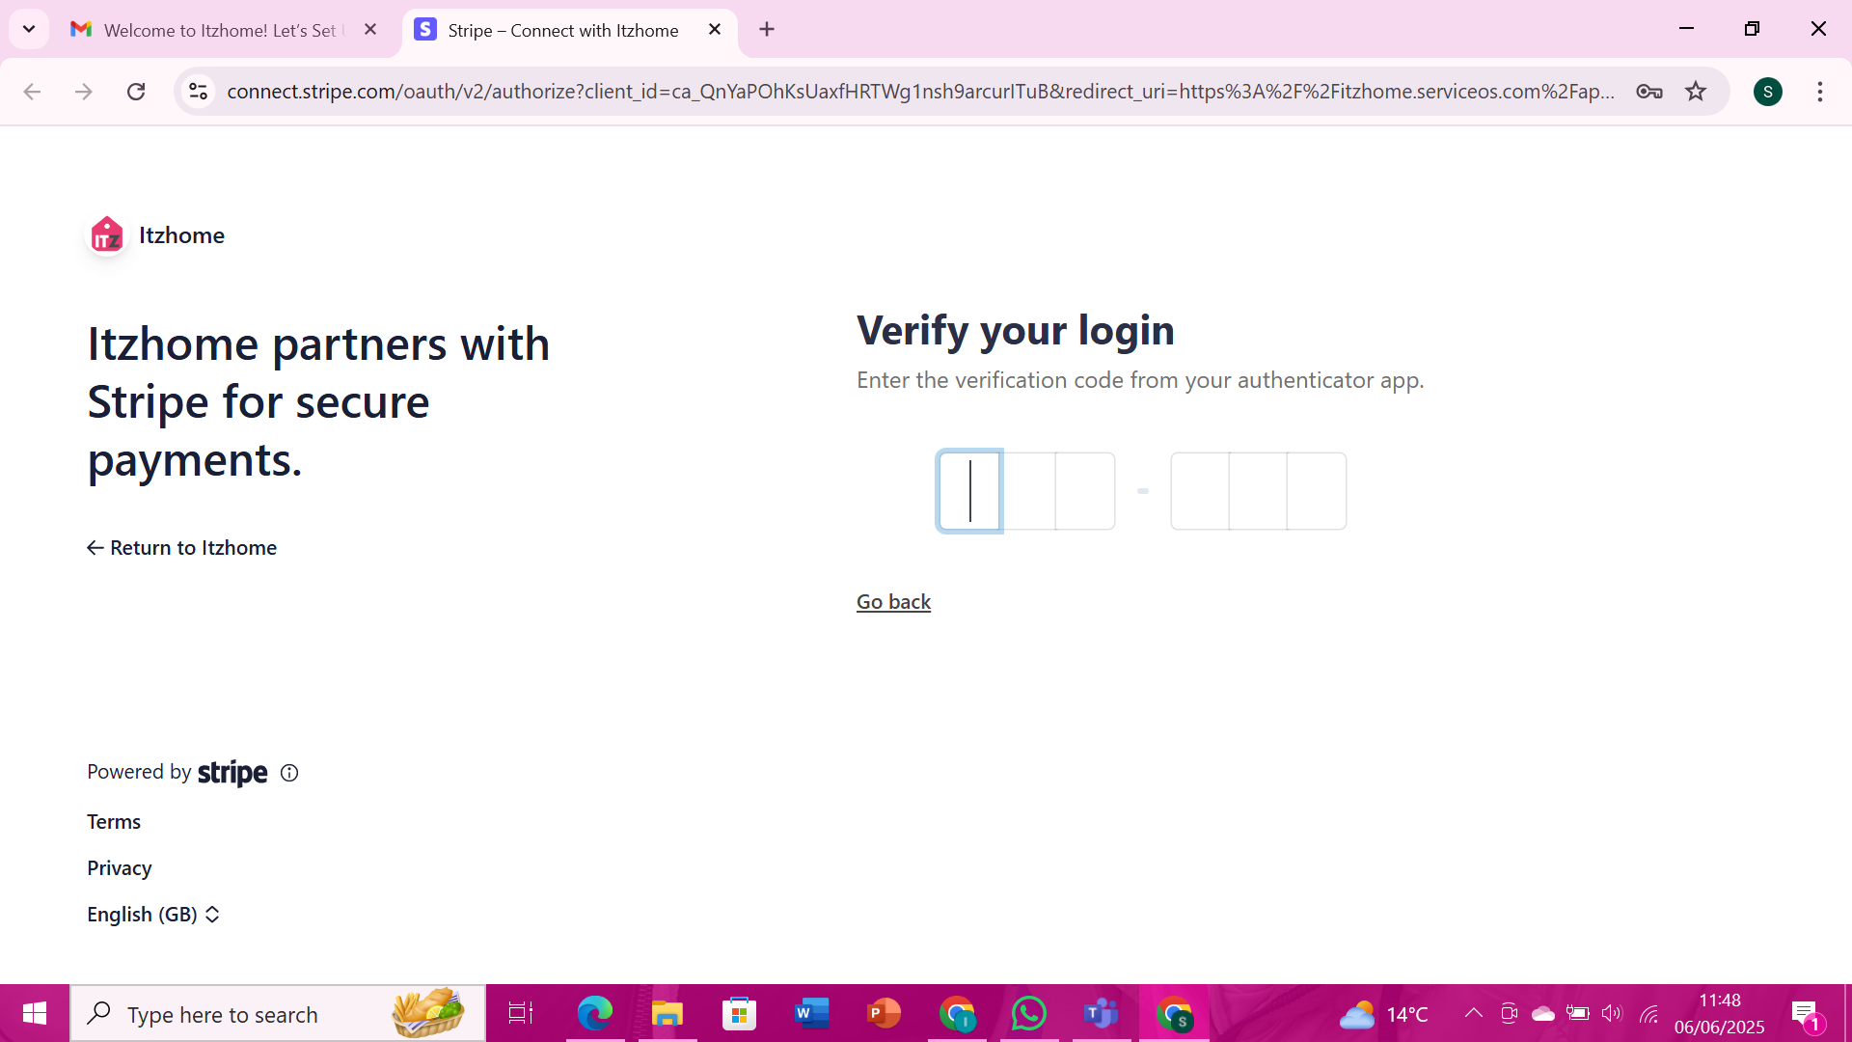

IMPORTANT!!!
- Save your backup code somewhere safe and click Next. You will need this if for some reason you can’t access your stripe account in the future. Itzhome do not keep copies of these codes.
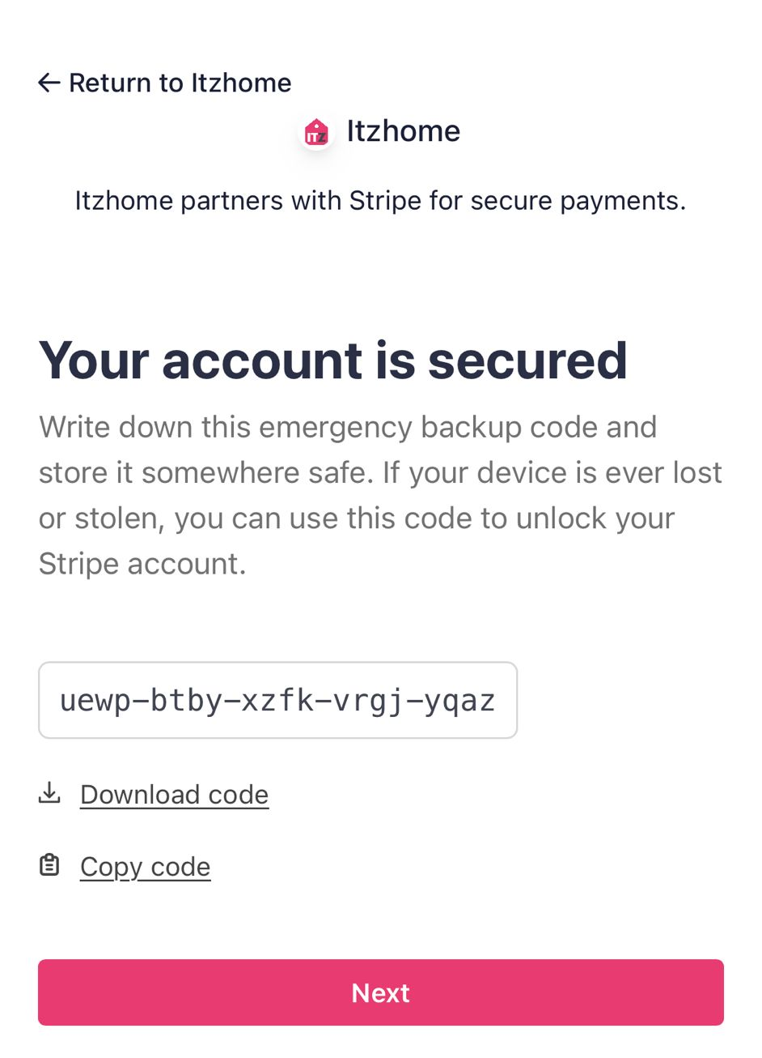

3. Business Details
- Select:
- - Business Location: United Kingdom
- - Business Type: Sole Trader
- 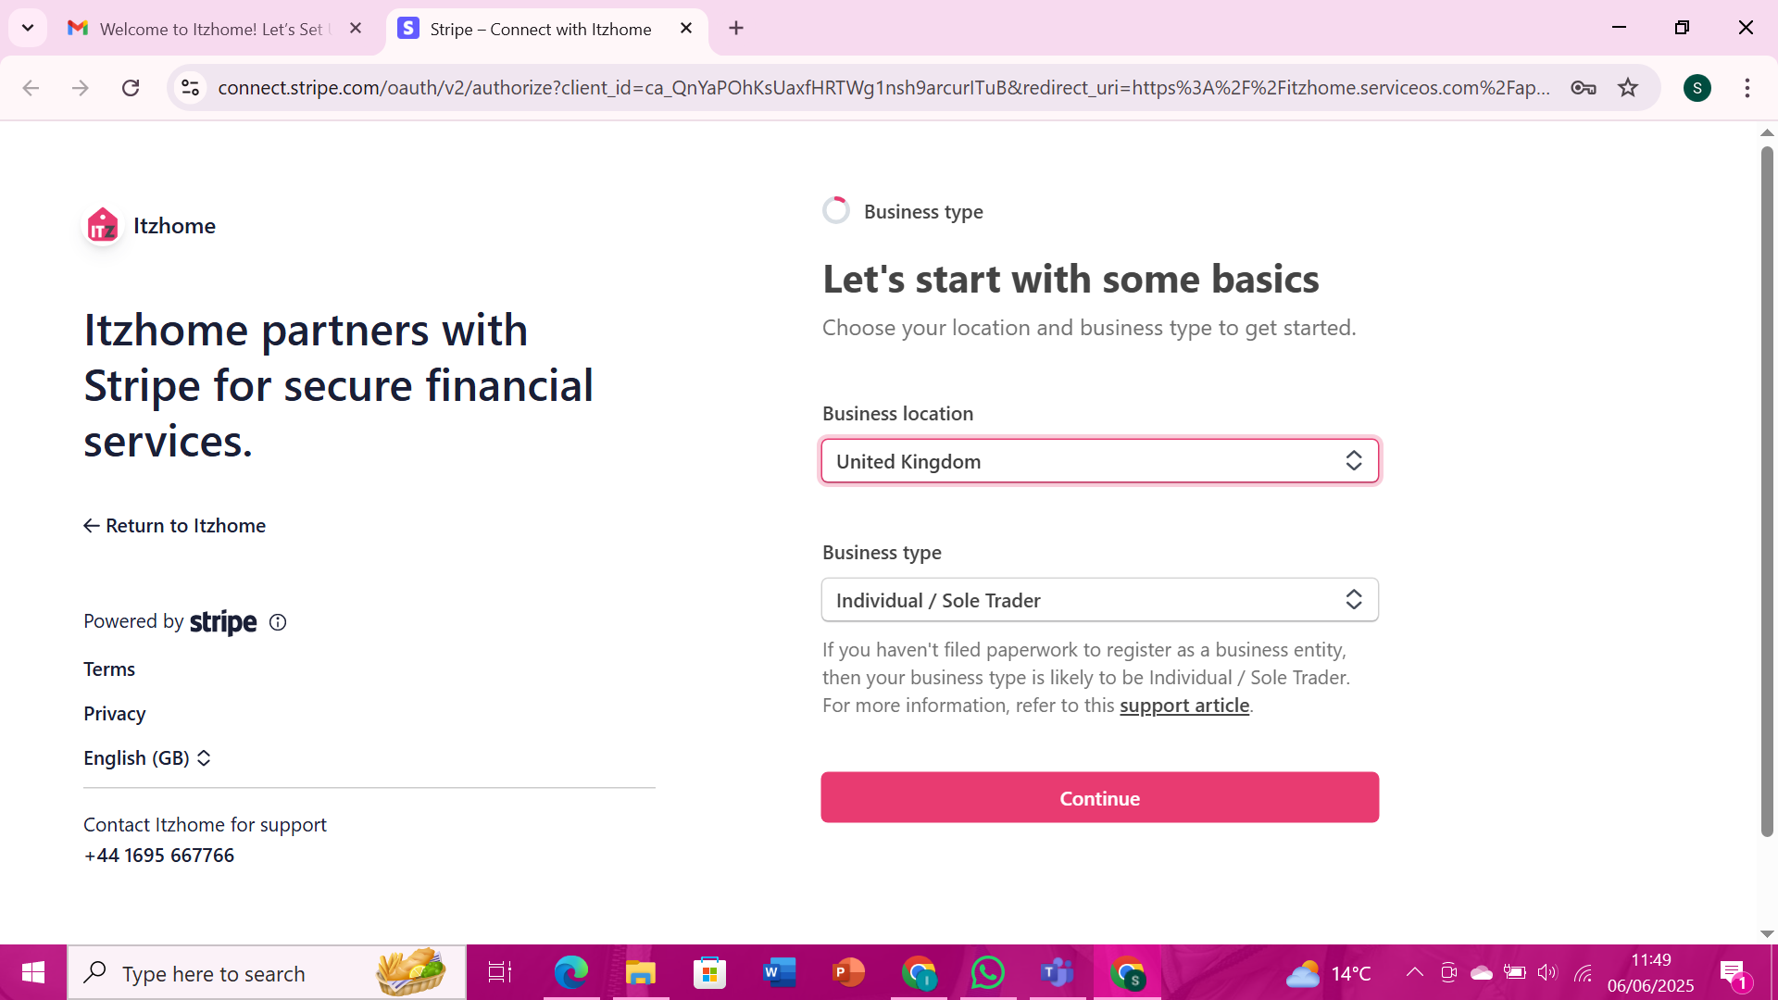Click Continue

4. Enter Personal Information
- Fill in the following:
- - Full Name
- - Date of Birth
- - Home Address
- - Phone Number
- 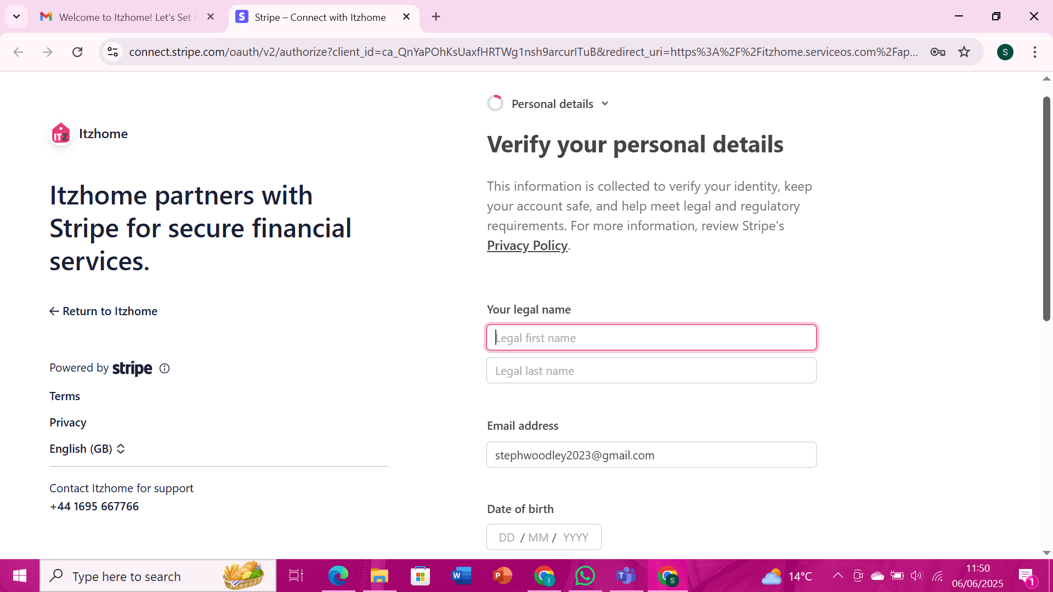Click Continue

5. Business Information
- VAT Number: Leave blank
- Industry: Choose Personal Services and then Laundry Cleaning
- Website: www.itzhome.com/warrington-cleaning (this is an example, you will need to change the town name with the area you are servicing and change the service to the service you are offering. The URL MUST NOT contain HTTPS) – if you are not sure on your area please contact your branch manager
- Product Description: Self-employed cleaner using the Itzhome platform. Carrying out a range of services from regular cleans to deep cleans.
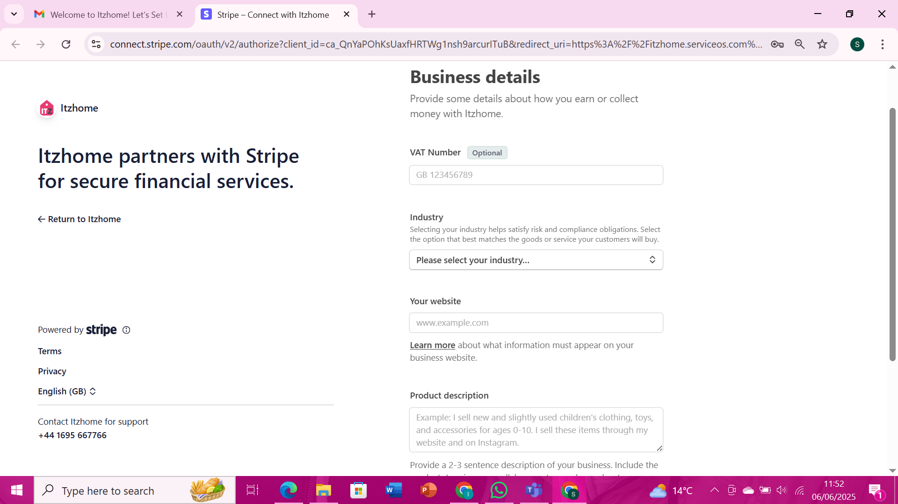Click Continue

6. Enter Bank Details
- Provide your Bank Account Information
- Set Payout Schedule to Manual
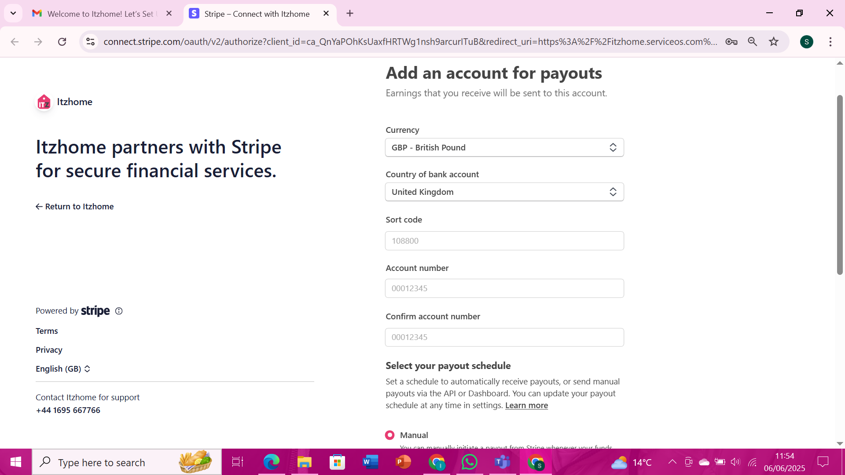Click Continue

7. Statement Information
- Statement Descriptor: Enter your Full Name
- Shortened Descriptor: Leave blank
- Customer Service Number: Your mobile number
- Turn OFF: “Show phone number on customer statements”
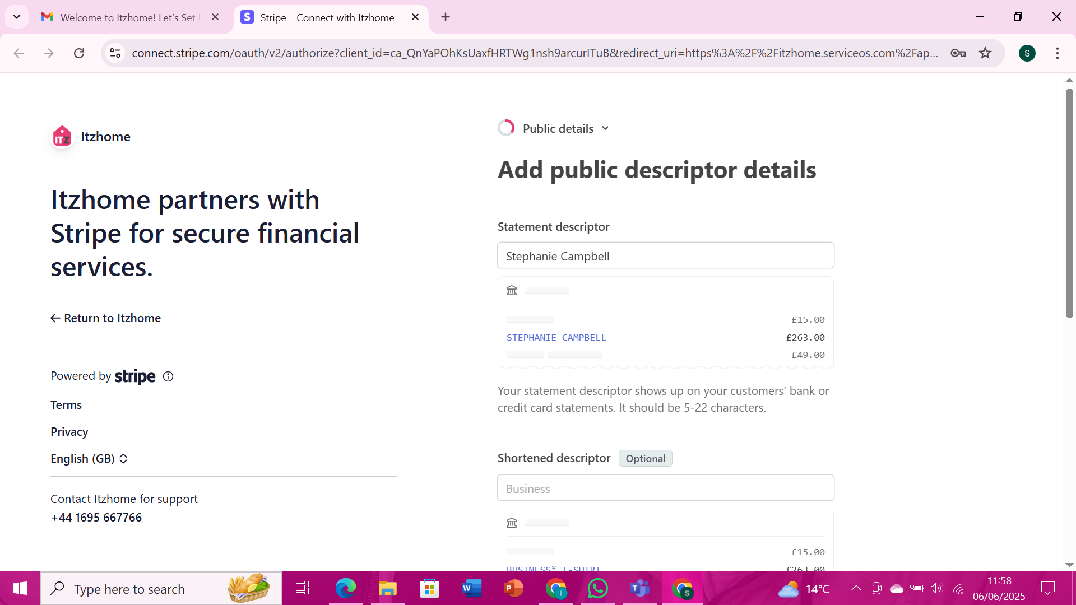Click Continue

8. Final Steps
- Click Skip or Not Right Now if asked about extra features
- 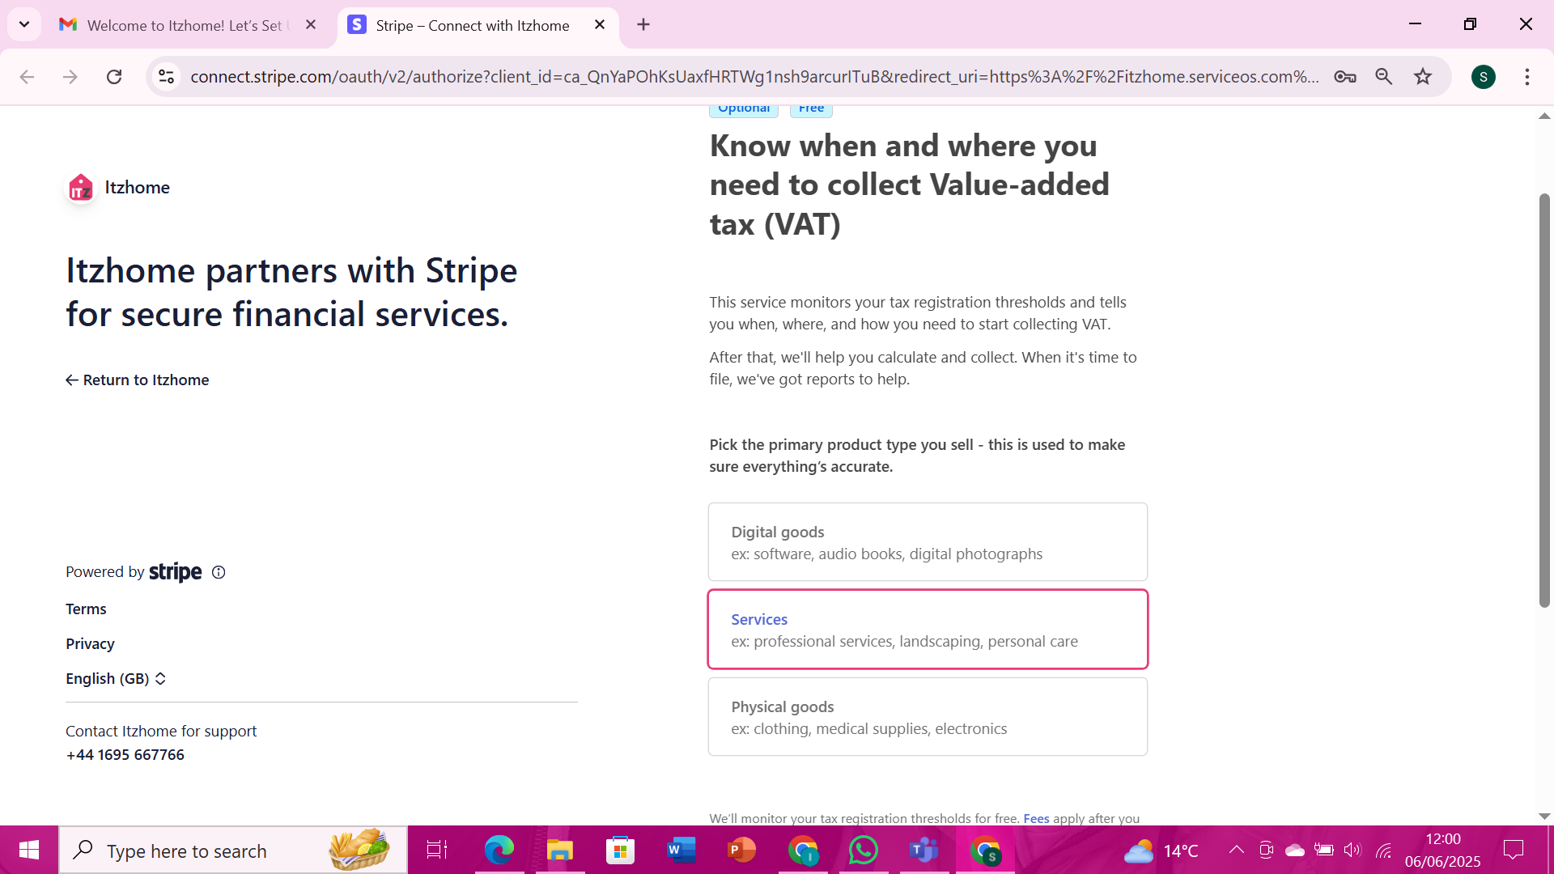Review all your information

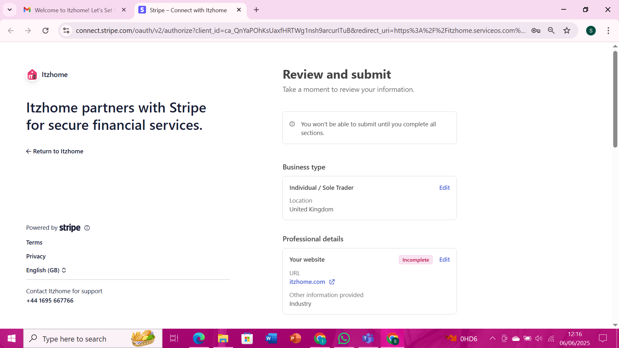Click Submit
- You're all set up!
