

Setting up your Stripe Account – Sole Trader

1. Start the Signup Process
- Click the link in the email titled – “Welcome to Itzhome! Lets Set Up Your Account for Smooth Payouts”

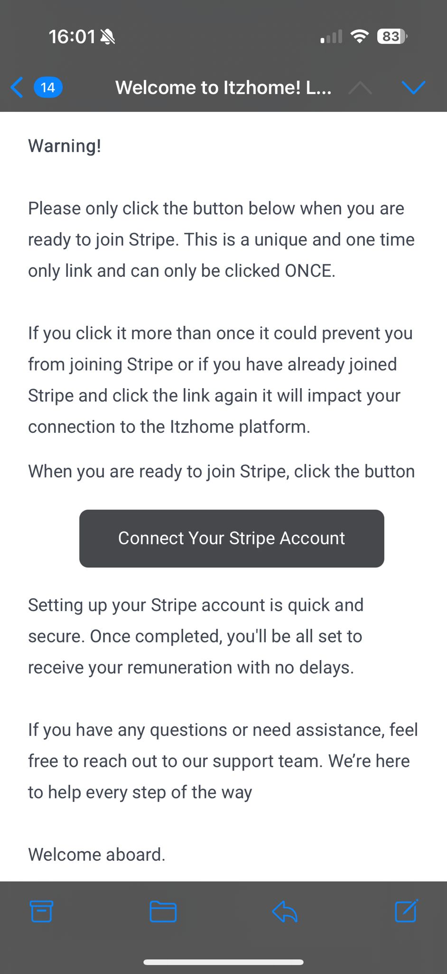

- Enter your email address and click Submit
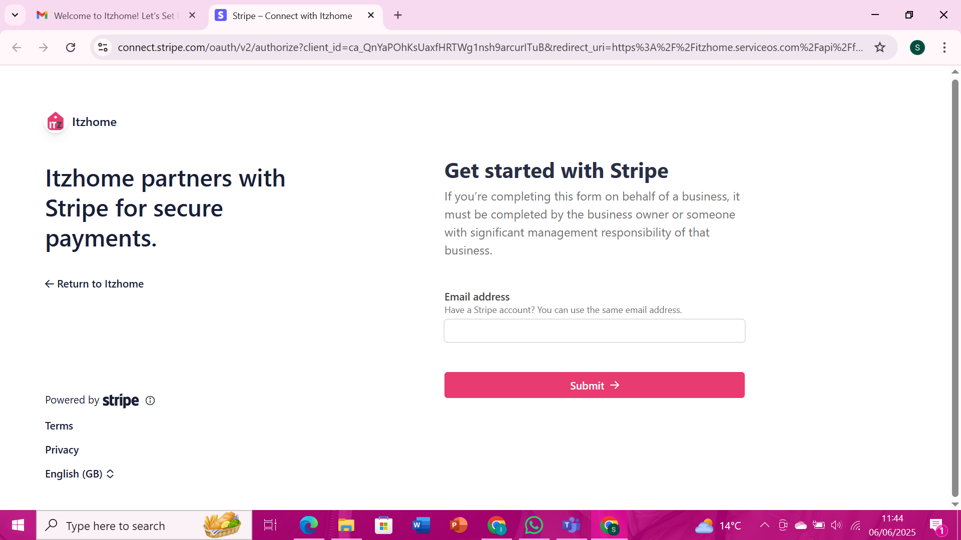

- Create a password and click Submit

2. Mobile Authentication
- Enter your mobile number here and a SMS with a 6 digit code will be sent to your phone to enter in stripe.
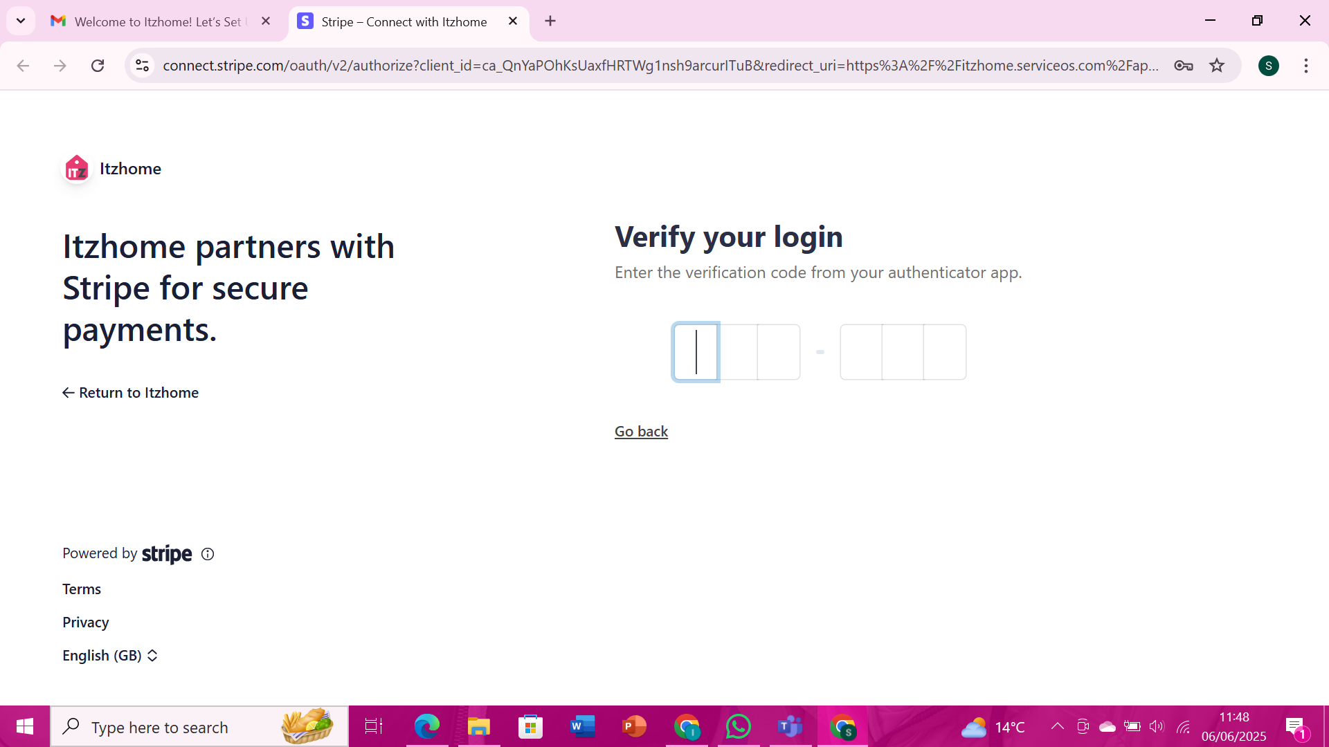

3. Business Details
- Select:
- - Business Location: United Kingdom
- - Business Type: Sole Trader
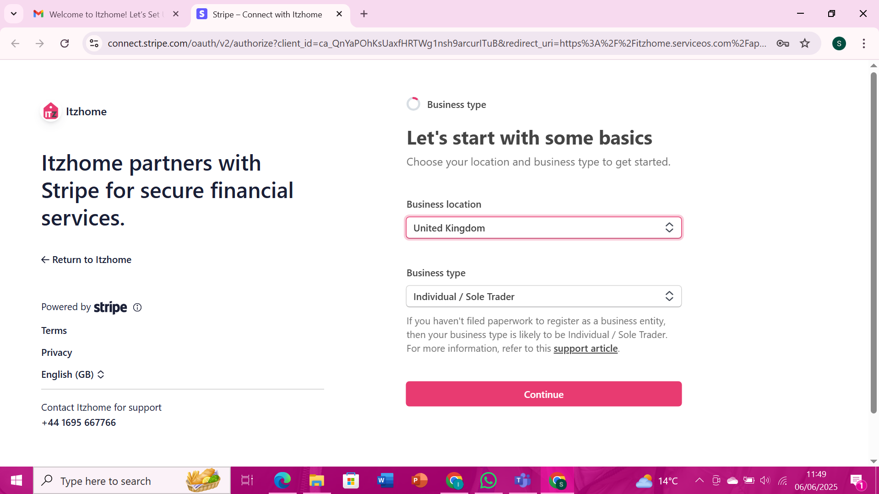

Click Continue

4. Enter Personal Information
- Fill in the following:
- - Full Name
- - Date of Birth
- - Home Address
- - Phone Number
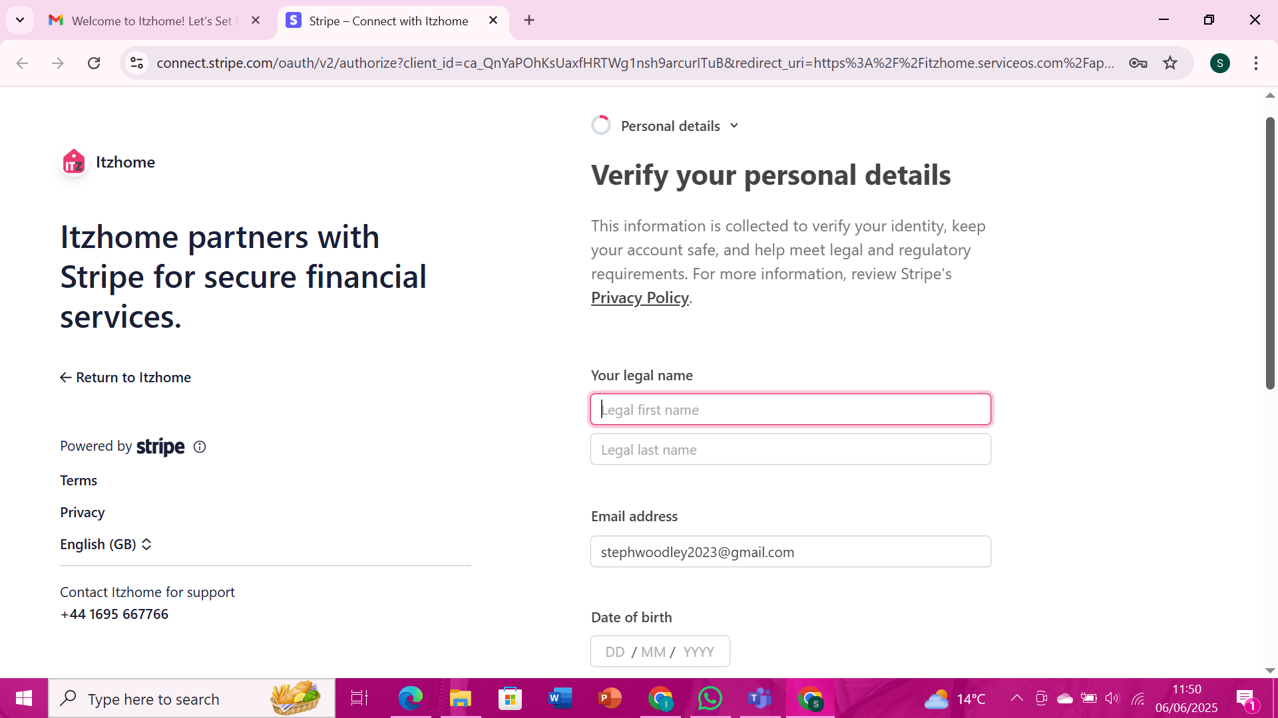

Click Continue

5. Business Information
- Industry: Choose Personal Services and then Laundry Cleaning
- Click on “Don’t have a website? Add product description instead
- Product Description: I am a <role> offering <service you offer>
- Click Continue
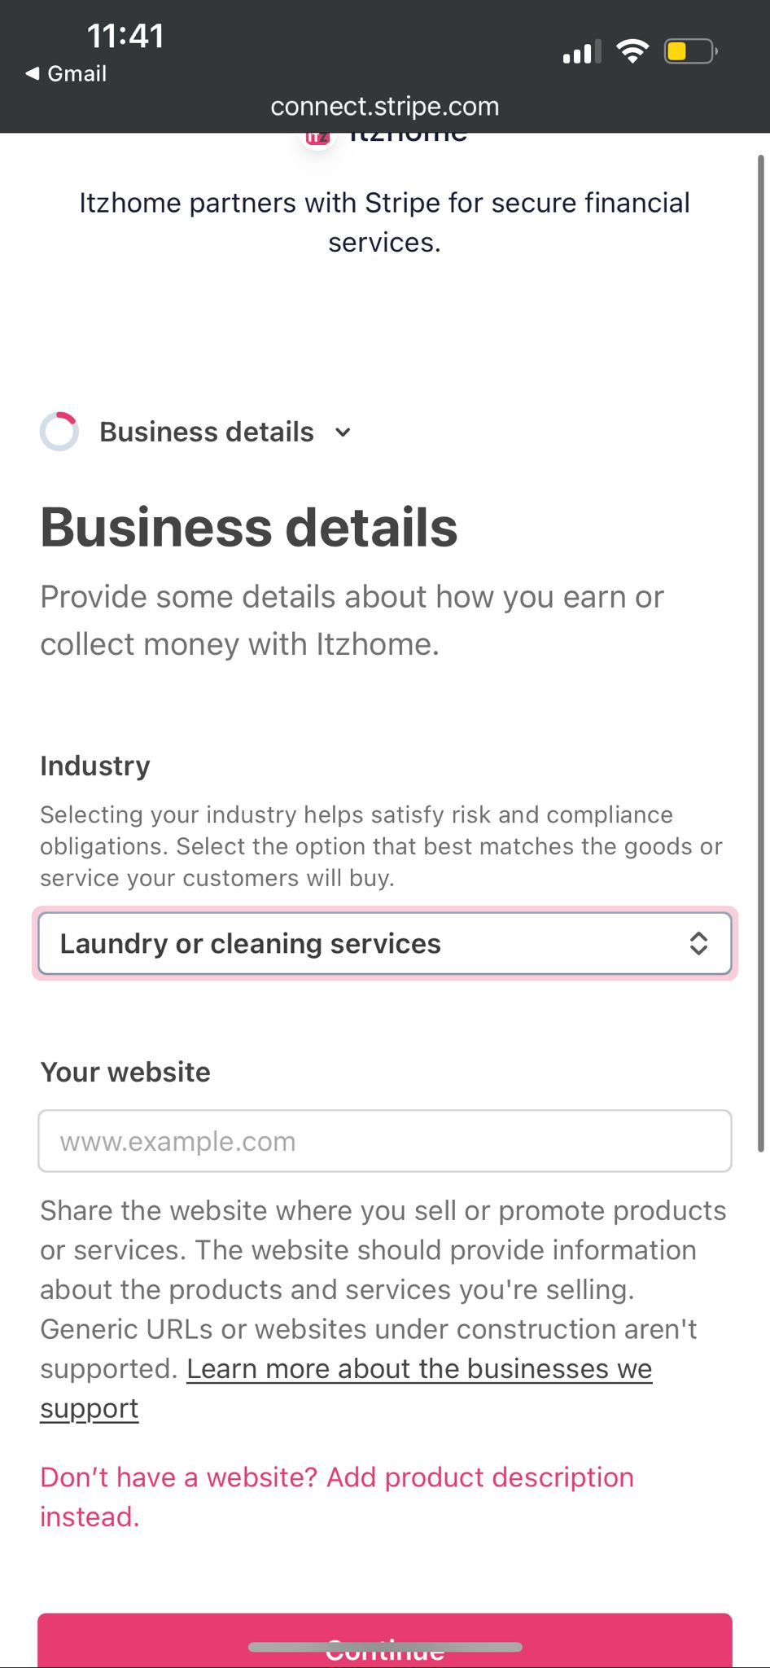

6. Verify your identity
- You will need to choose the authentication method to verify your identity
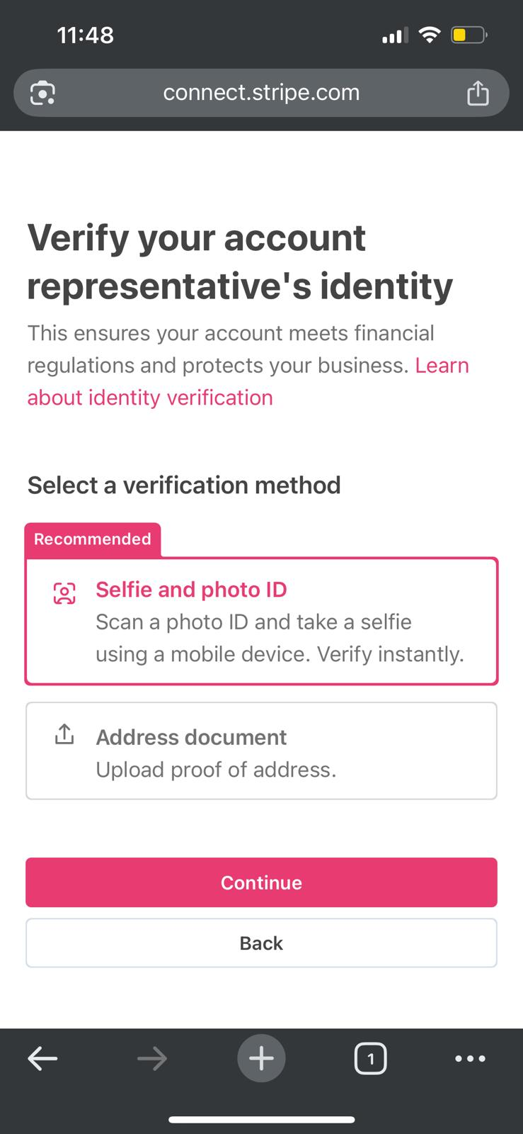

7. Enter Bank Details
- Provide your Bank Account Information
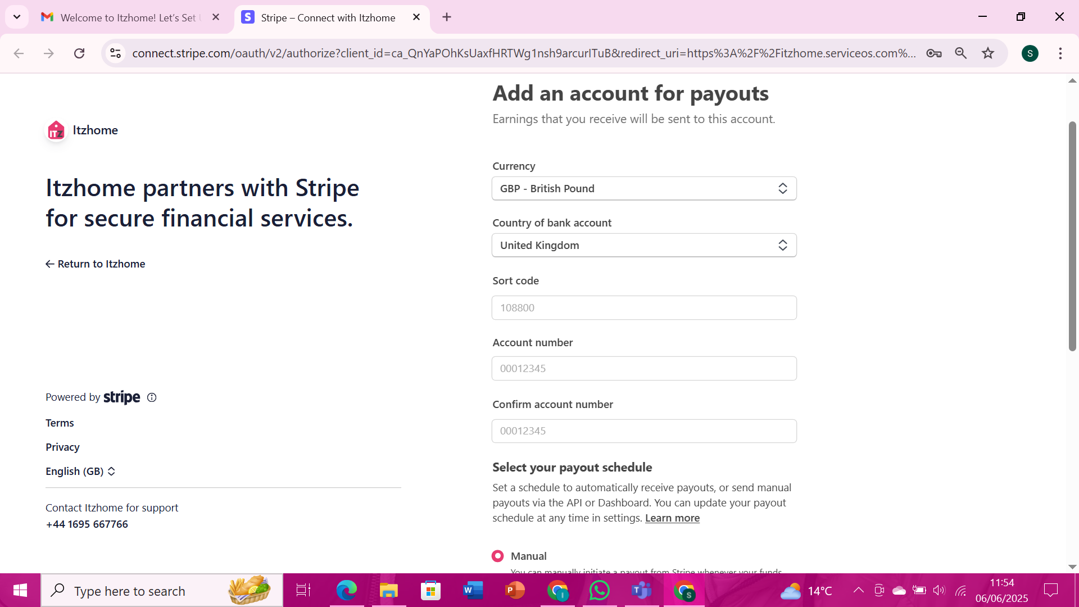
Click Continue

8. Review and Submit your details
- Click Submit
- You're all set up!
